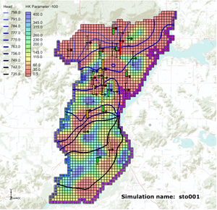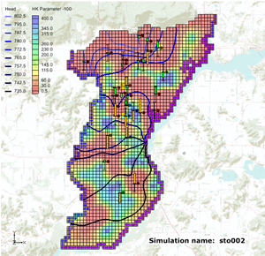

GMS 10.9

GMS 10.9 Tutorial

***MODFLOW – Stochastic Modeling, PEST Null Space Monte Carlo II***

Use results from PEST NSMC to evaluate the probability of a prediction

Objectives

Learn how to use the results from a PEST Null Space Monte Carlo (NSMC) simulation to set up a new stochastic simulation with MODFLOW.

Time

* 35–50 minutes

Required Components

* GMS Core
* MODFLOW Interface
* PEST
* Stochastic & T-PROGS

Prerequisite Tutorials

* MODFLOW – Stochastic Modeling, PEST Null Space Monte Carlo I

|  |
| --- |
| 1 Introduction 2  2 Getting Started 3  2.1 Importing the Project 4  3 Using the NULL Space Monte Carlo Method 5  3.1 The MODFLOW Run Options 5  3.2 Creating the new well 6  3.3 Removing the observations 7  3.4 Saving the Project and Running MODFLOW 7  3.5 Importing and Viewing the MODFLOW Solutions 8  3.6 Risk Analysis 9  4 Conclusion 11 |

# Introduction

GMS supports parameter randomization, indicator simulations (T-PROGS), and PEST Null Space Monte Carlo (NSMC) as methods for performing stochastic simulations. This tutorial will explain features of GMS associated with the PEST NSMC method. The former approaches are described in separate tutorials. It is highly recommended that the “MODFLOW – Stochastic Modeling, PEST Null Space Monte Carlo I” tutorial be completed prior to this tutorial.

The “MODFLOW – Stochastic Modeling, PEST Null Space Monte Carlo I” tutorial discussed how the NSMC method is used to create multiple calibrated MODFLOW models. This exercise is useful for exploring uncertainty associated with the calibrated model. However, a groundwater model is normally used to help make some kind of future prediction. The usual process for using a model to make a prediction is to use historical data to create a calibrated groundwater model and then modify the calibrated model to account for some future scenario and evaluate the prediction.

For example, to figure out how much drawdown a well would cause if an area was in a drought for a prolonged period of time, first create a calibrated groundwater model using historical information on water levels, pumping rates at wells, and rainfall. The calibrated model would be used as a starting point, the inputs would be modified to simulate a drought, and the model would be run. The model outputs would then be reviewed and a prediction would be made on the amount of drawdown caused by a well in such a scenario.

Uncertainty is always associated with various inputs (hydraulic conductivity, recharge, water levels, and so on) to the groundwater model. All have error associated with their input values. More often than not, the model is better than a scientific guess because the study area has been analyzed and the different processes that affect groundwater have been taken into account when building the model. Because historical data was used to make sure that the model matches what has been measured in the past, the model is better than a less sophisticated approach.

NSMC is a method for quantifying the amount of uncertainty associated with the prediction. Instead of creating a single calibrated model, PEST NSMC is used to create multiple calibrated models. The model can be modified to account for future conditions, then multiple models can be run using the different parameter values that PEST calculated. A distribution of results for this prediction can then be viewed.

The previously-mentioned drawdown example can present a mean drawdown with a standard deviation instead of presenting a single value. In this way, the prediction is much more solid because the amount of uncertainty associated with the prediction has been quantified. If the amount of uncertainty is unacceptably high, then more work may be required, such as collecting more field data or better calibrating the original model.

A groundwater model for an unconfined alluvial aquifer in Wisconsin, USA, is shown in Figure 1. The alluvium is highly variable in terms of hydraulic conductivity. In some areas, it is composed of well-sorted gravels with high conductivity, while in other areas it is composed of sandy silts with low conductivity. The location and description of the model area are accurate, but the observation wells used in this exercise are not field-measured values.

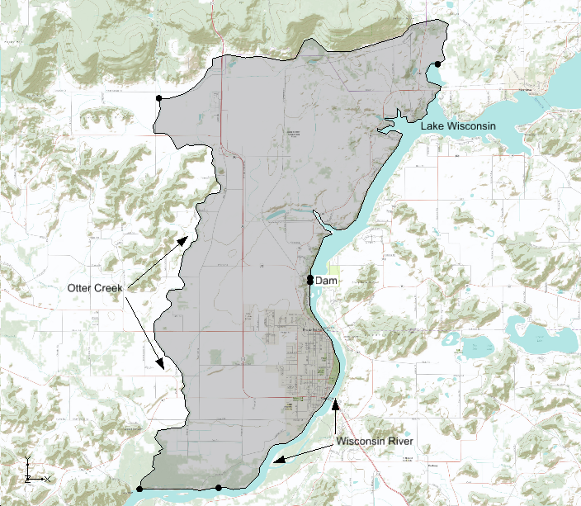

Figure 1 Study area

The model is bounded on the east by Lake Wisconsin and on the south by the Wisconsin River. A stream (Otter Creek) is used as the western boundary. Based on observed heads, it is assumed that there is a significant amount of recharge occurring along the northern boundary. The aquifer becomes very thin as on the northern and western boundaries.

This tutorial discusses and demonstrates opening a project with multiple calibrated MODFLOW solutions that were calibrated using PEST NSMC. The tutorial modifies the MODFLOW simulation, sets up a stochastic run using the results from PEST NSMC, and then runs MODFLOW in stochastic mode.

# Getting Started

Do the following to get started:

1. If necessary, launch GMS.
2. If GMS is already running, select *File |* **New** to ensure that the program settings are restored to their default state.

## Importing the Project

First to import a project containing the MODFLOW solution:

1. Click **Open** File:Open Macro.svg to bring up the *Open* dialog.
2. Select “Project Files (*.gpr)” from the *Files of type* drop-down.
3. Browse to the *Tutorials\MODFLOW\sto_pest_nsmc_II* directory and select “nsmcII.gpr”.
4. Click **Open** to import the project and exit the *Open* dialog.

A one-layer MODFLOW model with observation wells should appear (Figure 2).

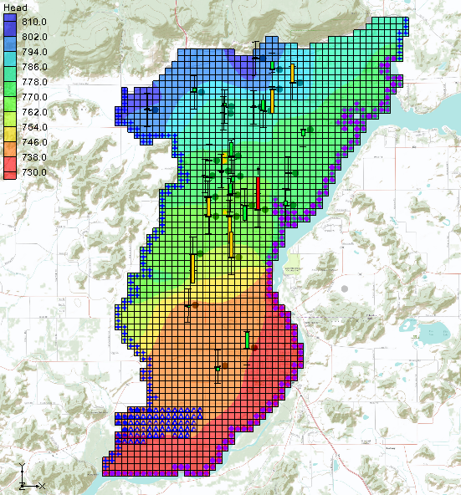

Figure 2 Calibrated MODFLOW model

1. Fully expand the “File:3D Grid Folder.svg 3D Grid Data” folder in the Project Explorer.
2. Select the “File:Generic Folder Locked.svg nsmcII001 (MODFLOW)” solution.
3. Alternate between each of the other solutions and review the variability in the computed heads between them.
4. Double-click on “File:External Text File Icon.svg nsmcII.mfo” in the Project Explorer to bring up the *View Data File* dialog. If *Never ask this again* has been previously turned on, this dialog will not appear. If this is the case, skip step 9.
5. Select the desired text editor from the *Open with* drop-down and click **OK** to open the MFO file in the desired text editor and close the *View Data File* dialog.

The file will open in the selected text editor (Figure 3). This file describes the PEST NSMC run.

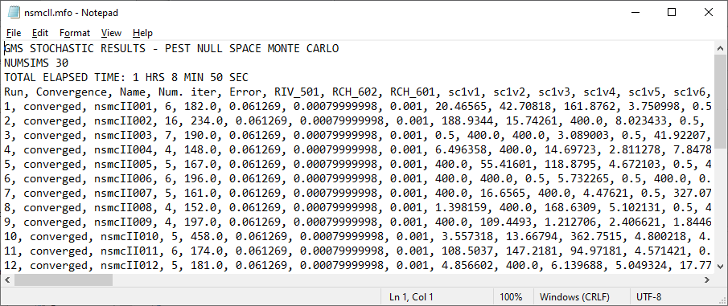

Figure 3 Stochastic output file (nsmcII.mfo) displayed in Notepad

1. Scroll through the file to see that this stochastic simulation comprised 30 different models.

Each line in the file describes a model run. Notice that the name of the simulation, the number of PEST iterations, the model error, and the parameter values are given on each line.

The original calibrated model had a total model error of 197.5. During the NSMC run, PEST would run each model until the total model error was less than 200.0 (the value specified for the PEST input parameter PSTOPTHRESH). Model runs 2, 10, and 21 had model error above the 200.0 and so they were removed from the stochastic folder in the project explorer. Model run 29 encountered some kind of problem so it was reported as a failed run.

1. Close the text file and return to GMS.

# Using the NULL Space Monte Carlo Method

## The MODFLOW Run Options

Now, modify the MODFLOW run to analyze the capture zone of a proposed well using the steps below. Then run MODFLOW in stochastic mode using the results from the PEST NSMC run.

1. Select *MODFLOW* | **Global Options…** to open the *MODFLOW Global/Basic Package* dialog.
2. In the *Run options* section, select *Stochastic*.
3. Click **Stochastic Options…** to open the *Stochastic Options* dialog.

This dialog is used to change the stochastic options. The PEST NSMC option is still going to be used, but it is necessary to select the PEST NSMC stochastic solution that will be used as input for the new stochastic simulation.

1. To the right of *PEST NSMC* select “nscmII (MODFLOW)(STO)” from the drop-down.
2. Click **OK** to exit the *Stochastic Options* dialog.
3. Click **OK** to exit the *MODFLOW Global/Basic Package* dialog.

## Creating the new well

1. **Zoom** File:Zoom Tool Icon.svg in by dragging a box around the area shown in Figure 4.

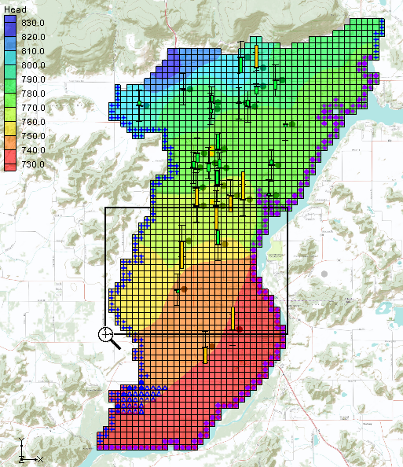

Figure 4 Area in model where new well will be created

1. Under the “File:Conceptual Model Icon.svg Lake Wisconsin” conceptual model, select the “File:Coverage Active Icon.svg wells” coverage to make it active.
2. Select “File:3D Grid Icon.svg grid” to make it active.
3. Using the **Select Cells** File:Select 3D Cell Tool.svg tool, select Cell ID 2356 (Figure 5).

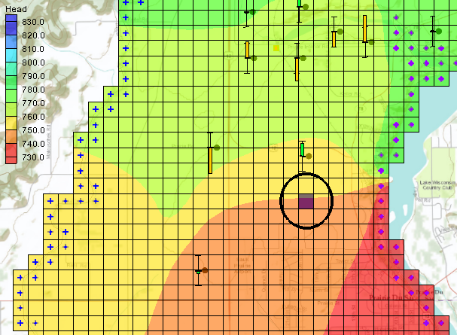

Figure 5 Location of new well in Cell ID 2356

1. Right-click on the selected cell and select **Sources/Sinks…** to open the *MODFLOW Sources/Sinks* dialog.
2. From the list on the left, select *Wells (WEL)*.
3. Click **Add BC** to create a new well.
4. In the *Name* column on the *2356* row, enter “Well 4A”.
5. In the *Q (flow) (ft^3/d)* column on the *2356* row, enter “-65000.0”.
6. Click **OK** to exit the *MODFLOW Sources/Sinks* dialog.
7. **Frame** File:Frame Macro.svg the project.

## Removing the observations

It is necessary to remove the head observations since a model scenario that is inconsistent with these head measurements is being run.

1. Select *MODFLOW |* **Observations…** to open the *Observations* dialog.
2. In the *Coverages (head observations)* section, uncheck the box in the *Use* column in the spreadsheet.
3. Click **OK** to exit the *Observations* dialog.

## Saving the Project and Running MODFLOW

Now to save the project and run PEST in stochastic mode:

1. Select *File* | **Save As…** to bring up the *Save As* dialog.
2. Select “Project Files (*.gpr)” from the *Save as type* drop-down.
3. Enter“nsmcII_forward.gpr” as the *File name*.
4. Click **Save** to save the project under the new name and close the *Save As* dialog.
5. Select *MODFLOW* | **Run MODFLOW** to bring up the *Stochastic MODFLOW* dialog.

MODFLOW is now running in stochastic mode. The spreadsheet in the top section shows the parameter values for each model run and whether the model converged. Below the spreadsheet, a text window displays the output that MODFLOW prints to the screen when running MODFLOW from the command line.

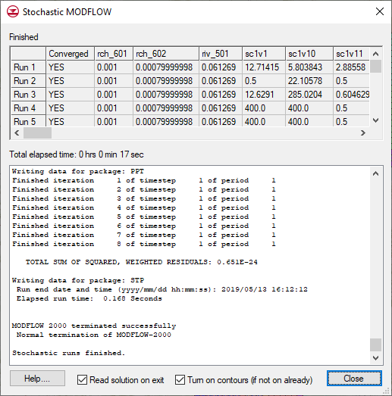

Figure 6 Stochastic MODFLOW dialog

For each model run, GMS reads the parameter values calculated by PEST in the previous NSMC run and saves those parameter values to the SEN package file for MODFLOW 2000 or to the PVAL package file for MODFLOW 2005 and NWT. MODFLOW then executes that model run. This process may take several minutes.

## Importing and Viewing the MODFLOW Solutions

Once all the MODFLOW runs are completed, import the solutions.

1. Turn *Read solution on exit* and *Turn on contours (if not on already)*.
2. Click **Close** to close the *Stochastic MODFLOW* dialog and open the *Reading Stochastic Solutions* dialog.
3. Click **OK** to close the *Reading Stochastic Solutions* dialog and import all converged solutions.
4. Expand the new “File:Generic Folder.svg nsmcII_forward (MODFLOW)(STO)” folder in the Project Explorer and review the individual solutions.

## Risk Analysis

Now, use the “nsmcII_forward” set of stochastic solutions to examine the capture zone for the new well.

1. Right-click on the “File:Generic Folder.svg nsmcII_forward (MODFLOW)(STO)” folder in the Project Explorer and select the **Risk Analysis…** to bring up the *Risk Analysis Wizard* dialog.
2. Below the list, select *Probabilistic capture zone analysis*.
3. Click **Next** to go to the *Capture Zone Analysis* dialog.
4. In the *Particle termination at cells with weak sinks* section, select *Stop in cells with weak sinks*.
5. Click **Finish** to close the *Capture Zone Analysis* dialog.

GMS is now running MODPATH on each of the MODFLOW solutions. A particle is placed on the water table surface at each cell in the model grid and then the particle is tracked forward in time to determine the cell where the particle terminates.

When the model finishes running, the Graphics Window will appear similar to Figure 7.

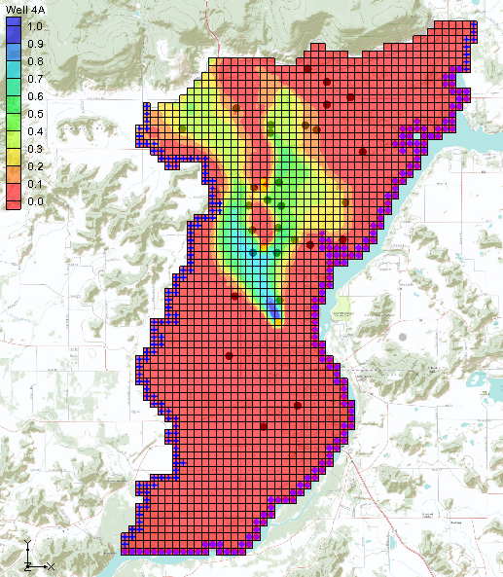

Figure 7 Probabilistic capture zone for proposed well

Figure 8 show capture zones from individual solutions computed by MODFLOW. Notice the difference in the shape and location of the various capture zones. This is due to the uncertainty associated with this model.

Even though the model has been calibrated to field-measured water level data, PEST NSMC can be used to create multiple calibrated models that show significant differences in the capture zone for the well. This makes it more reasonable to discuss modeling results in terms of uncertainty and probability than in terms of the results from a single model.

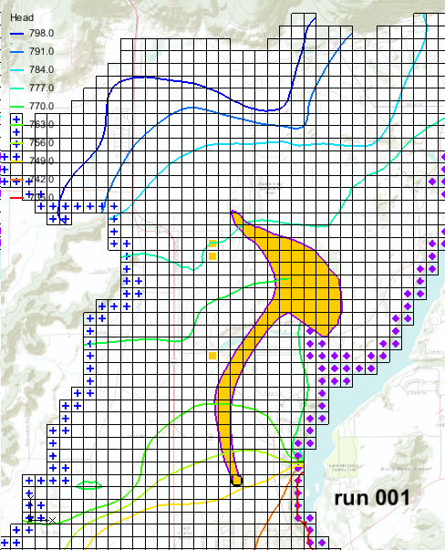 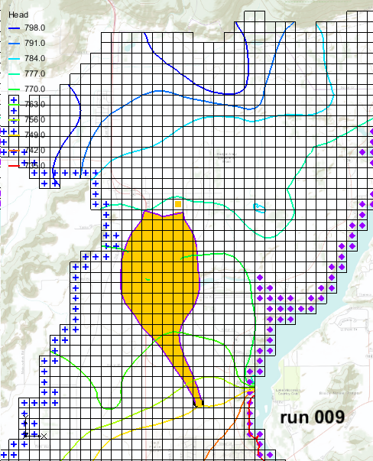

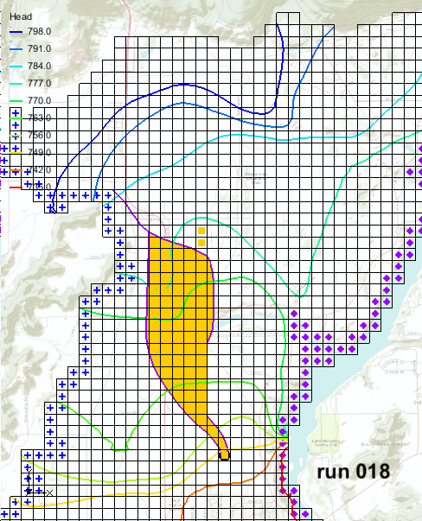 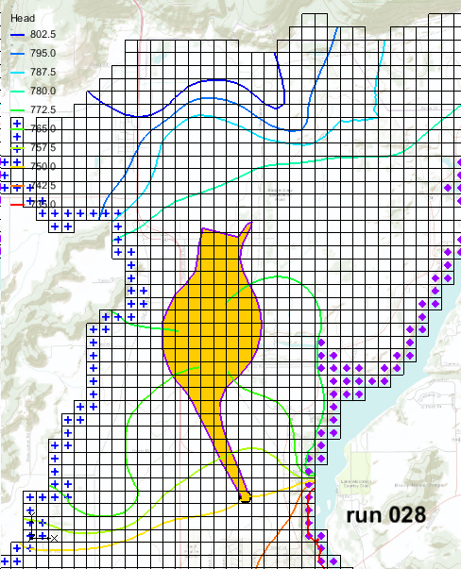

Figure 8 Capture zones from individual runs

# Conclusion

This concludes the “MODFLOW – Stochastic Modeling, PEST Null Space Monte Carlo II” tutorial. The following key concepts were discussed and demonstrated in this tutorial:

* Create a new stochastic solution using the results of a completed PEST Null Space Monte Carlo run.
* The Risk Analysis tools in GMS allow the creation of probabilistic capture zones.